Friday Maths Challenges
- HOUSE CHALLENGE
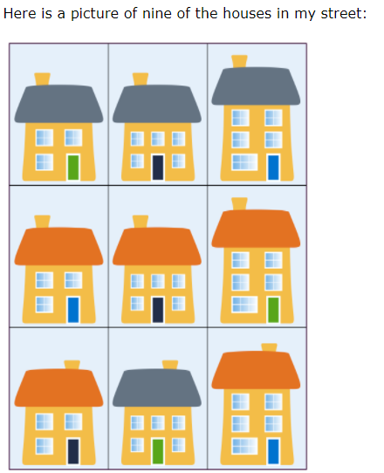

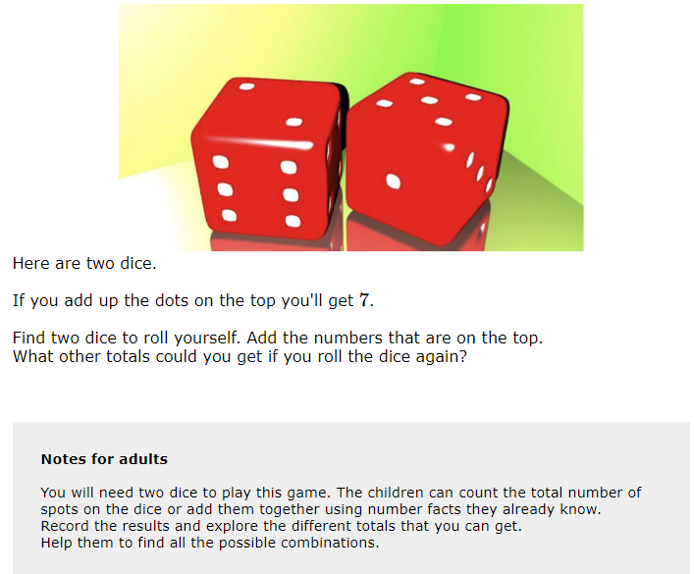
2) TWO DICE CHALLENGE
3) PAIRS OF NUMBERS CHALLNGE
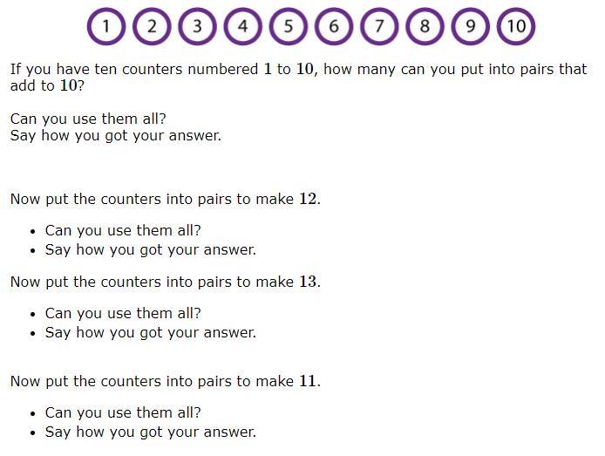

4) ONE OF 36 CHALLENGE
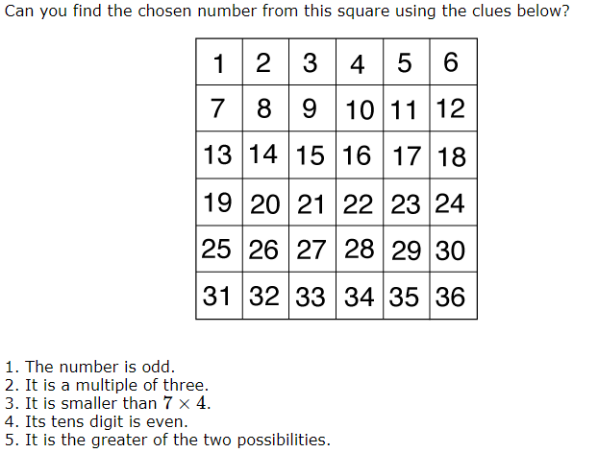

5) A CITY OF TOWERS CHALLENGE
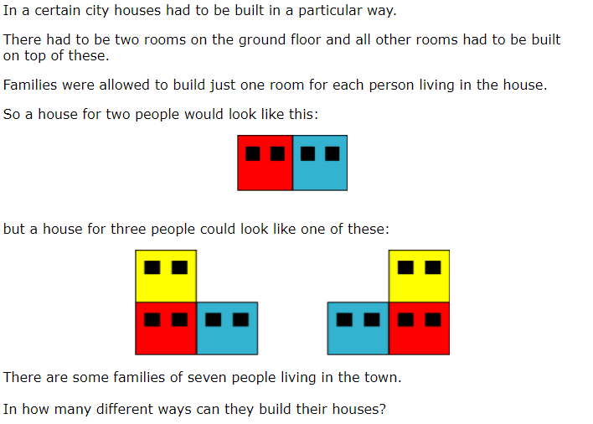

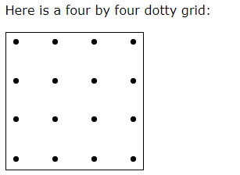
6 ) INSIDE TRIANGLES CHALLEGE
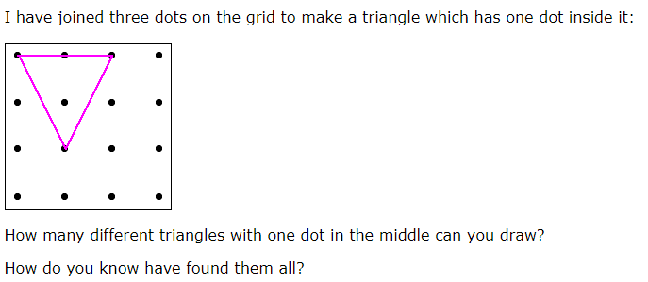
7) BUTTON UP CHALLENGE
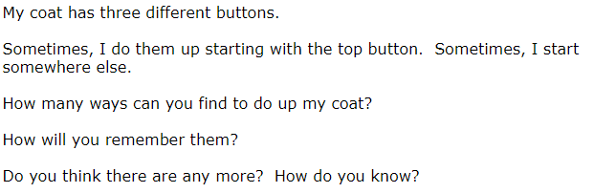

8) THREE BALLS CHALLENGE
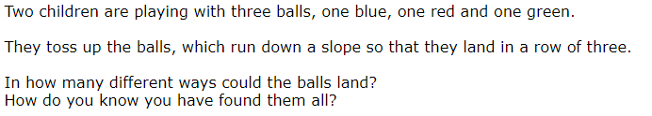
9) THE TALL TOWER CHALLENGE
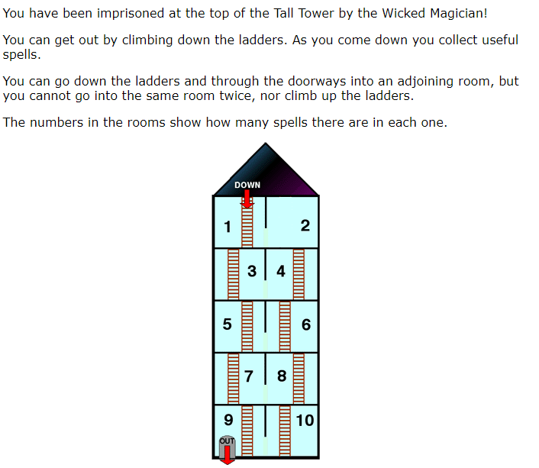
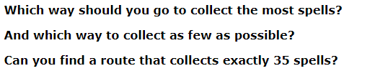

10) ROBOT MONSTER CHALLENGE
