Design Technology
Start Collecting kitchen roll and toilet roll card inners
Week 1 Paper Airplane Challenge
1.Make the following paper airplane.
2. Aim to fly in into a container or onto a mat.
3. How far did it fly?
4. Can you make alterations to your plane to get it to fly further?
5. Are there other designs that fly better than this one? Why are they better, what in the design do you think helps them fly better?
- DIG. 1
1
Firstly fold the sheet in half along the line shown in DIG. 1 and then open it out again.
- DIG. 2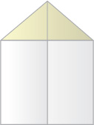
2
Fold the two top corners in to the centre line to give the form in DIG. 2
- DIG. 3
3
Then fold the top large triangle over so that the two flaps formed in step 2 are underneath the large triangle. Your paper should now look like DIG. 3
- DIG. 4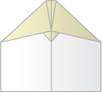
4
From the form in DIG. 3 fold the two top corners into the centre line again in such a way that you get the form in DIG. 4
- DIG. 5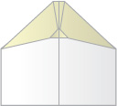
5
Now fold the small triangle up over the two flaps to give DIG. 5
- DIG. 6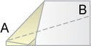
6
Fold along the centre line so that the small triangle is on the underside of the plane on the outside along with the two flaps as shown in DIG. 6
- DIG. 7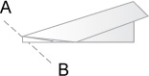
7
Fold along the line AB on DIG. 6 then turn the plane over and do the same to the other side producing DIG. 7.
- DIG. 8
8
Fold along the line labelled AB on the diagram first one way and then the other creasing really well. Tuck the triangular shaped depression in-between the two wings to produce DIG. 8. This stabilises the plane if you do not make it perfectly.

Paper Airplane Flying
This paper airplane is easy to throw. You should throw it overarm with the nose pointing slightly up while holding the plane about 1/4 of it's length from the front.
This paper airplane will fly a very long distance indeed. If you throw it outdoors and you have made it from a large piece of paper it can fly for hundreds of meters. If you throw it on a very hot day from an upper storey window it can catch thermals and then you're really talking!

Week 2 – Design a Boat
1.Select and look at pictures of boats.; look at different designs for various purposes. Look at the materials that are used for building boats, any pulley systems and sails.
2.List what boats can be used for.
Before starting Check with your Parents!
3. Draw a design of a boat using things that you have around the house. Draw and label the parts and the materials you plan to use.
What will help make your boat float?
What is your boat going to carry?
4. Make your boat.
5. Test your boat.

Week 3
Design a mode of transport, a house, or a game using toilet roll and kitchen towel holders.
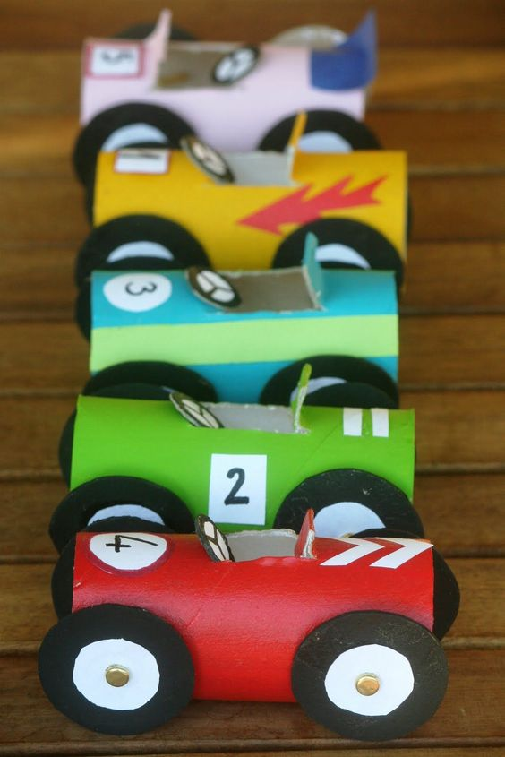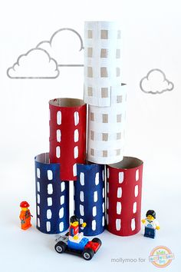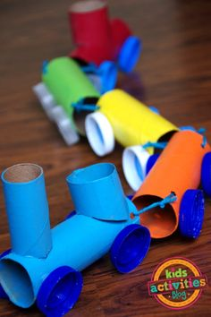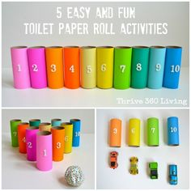

Week 4 Healthy Eating
Design a meal of your favourite foods.
Design another meal that you would like but using only healthy food.
Find out what a balanced meal is and list what would be on your plate.
Make a poster to encourage a younger child to eat healthily. What do you think they would like to eat that is healthy?

