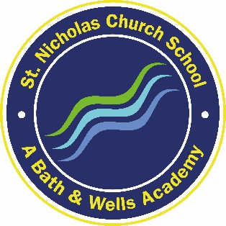
St. Nicholas Church School
Kilmersdon Road
Radstock
BA3 3QH

Tel 01761 432101

25th May 2021

Formal Consultation to increase by 10 key stage 1 places St Nicholas Church School Resource Base Provision ‘The Midford’ for pupils with Social, Emotional Mental Health Needs

Dear Parent,

From September 2021 it is proposed that we will open an additional 10 place key stage 1 class in our Learning Resource Base. This will be for pupils with an EHCP aged between 4 years and 7 years with social, emotional and mental health (SEMH) needs who are struggling in a mainstream classroom. Pupils will then progress through to our KS 2 resource base provision or into mainstream classes.

This proposal supports the increasing demand for specialist education provision across Bath and North East Somerset, a need which has grown significantly over the past 5 years. There is currently only our 10 place Learning Resource Base provision within the Midsomer Norton and wider BANES area. This proposal will therefore benefit pupils living locally but is not exclusive to those living within this area. It can be accessed by pupils across Bath and North East Somerset to support social, emotional and mental health (SEMH) needs in an appropriate and secure environment. There will be no detrimental impact on mainstream or supported provision at this school, or indeed at any other school across Bath and North East Somerset.
Children with Social, Emotional Mental Health difficulties may show inappropriate ways of coping with a range of emotional, social, environmental and personal situations. They may put barriers between themselves and their learning through inappropriate, aggressive or withdrawn behaviour. Such children often have poor social skills' development, low self-esteem, and little experience of consistent guidelines on how to behave and show limited skill in coping with frustration, anger and fear.
The resource base would provide a nurturing environment where staff are trained to support the emotional health of pupils and are able to provide a flexible and bespoke curriculum for those attending.

The accommodation would be self-contained within the school providing classroom, toilets, break out space and a separate play space.

Our school has a Mental Health support worker, therapist and psychotherapist contracted to the school who would be able to work with the additional pupils in the resource base.

The Bath and Wells Multi Academy Trust, Bath and North East Somerset Local Authority and the Local Governing Body are keen to support the opening of these additional places at specialist support provision at St Nicholas and would like to hear the views of families as part of the consultation process. There are already a number of students who have such a diagnosis and who very successfully attend St Nicholas and make great progress.

All students who are designated to the additional support provision will attend lessons within the resource base. Students who are designated as requiring resourced provision will have an Education and Health Care Plan and will have a place allocated by the Local Authority through the Special Educational Needs Panel at Bath and North East Somerset.

As a school we are confident that this new venture will be beneficial to all and will allow those with these needs the opportunity to consider mainstream provision in the future.

We would welcome your views on this matter either by email directly to enquiries@stnicholas.bwmat.org
Full details of the proposal can be found on our website at www.stnicholasschool.co.uk

The formal consultation regarding this starts on Monday 7th June 2021 and lasts until 23:00 4th July 2021.
We look forward to hearing your views.
Yours sincerely,

Nicola Smith
Headteacher

