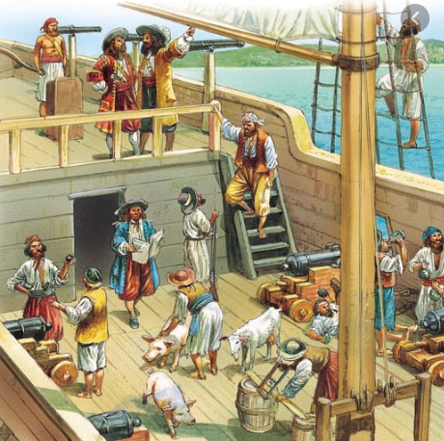

L.O: I can write instructions

The Captain of the ship always tells their crew what jobs to do.
- List some jobs the Captain needs to tell his crew to
do on board the ship.
- E.g. Pull up the sails, wash the deck etc.

________________________________________________________________________________________________________________________________________________________________________________________________________________________________________________________________________________________________________________________________________________________________________________________________________________________________________________________________________________________________________________________________________________________________________________________________________________________________________________________________________________________________________________________________________________________________________________________________________________________________________________________________

________________________________________________________________________________________________________________________________________________________________________________________________________________________________________________________________________________________________________________________________________________________________________________________________________________________________________________________________________________________________________________________________________________________________________________________________________________________________________________________________________________________________________________________________________________________________________________________________________________________________________________________________________________________________________________________________________________________________________________________________________________________________________________________________________________________________________________________________

