Hello Year 2,
We are going to be using Google Classrooms as a way of working together and keeping in touch. You should be able to access Google Classrooms from any internet enabled device but a device with a camera will be best if you would like your classmates to see you in the classroom.
There is so much we can do with Google Classrooms, but to begin, we’ll just focus on learning how to use the basics.
To use Google Classrooms, you need a Google email login. Your login can be found on the email sent to your VLE. Please note:
- Your Google email must ONLY be used for the purposes of school work. You must not use it to sign up to other websites, or use it to message other people.
- The email is monitored by staff at all times.
- Your Google Drive must only be used to store school work as directed by your teacher.
- The St Nicholas Online Safety Policy and Acceptable Use Agreement still apply when using Google Classroom at home.
- Any misuse of this service will result in your account being deactivated.
- Make sure you speak to a trusted adult if you have any concerns about using Google Classrooms.
If you are using an iPad or tablet please ensure you have downloaded the Google app as well as the Google meet app or you will not be able to connect.
Firstly, open up your internet browser and go to Google: www.google.com
Click on the sign in button on the top right of the screen.
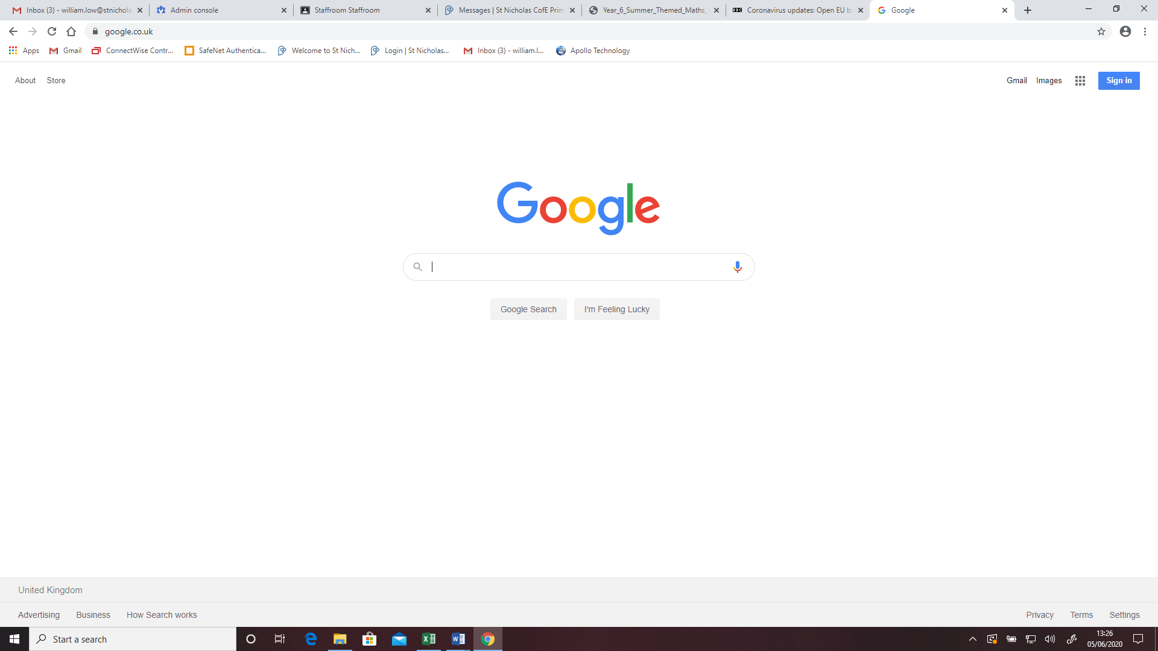

Next, enter your login details.

Once you have logged in, click on the Apps option in the top right corner.

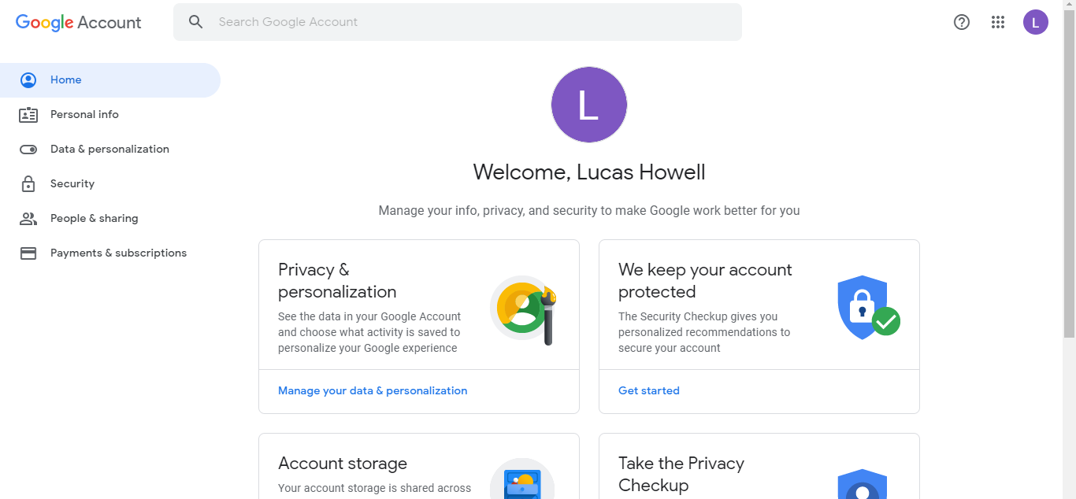

Now click on the Classrooms App

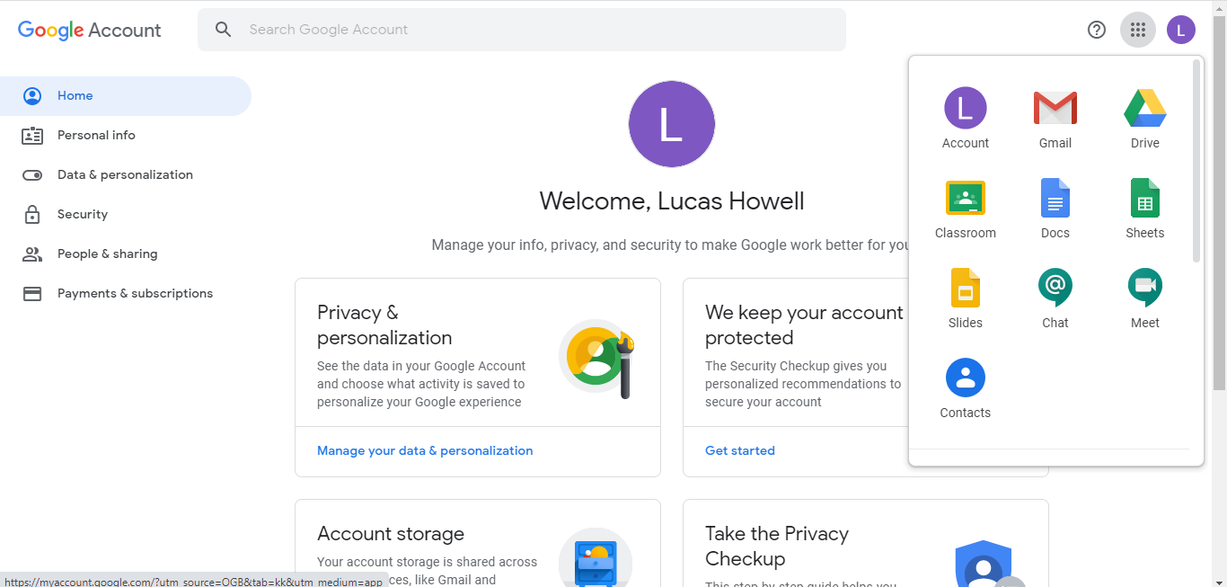

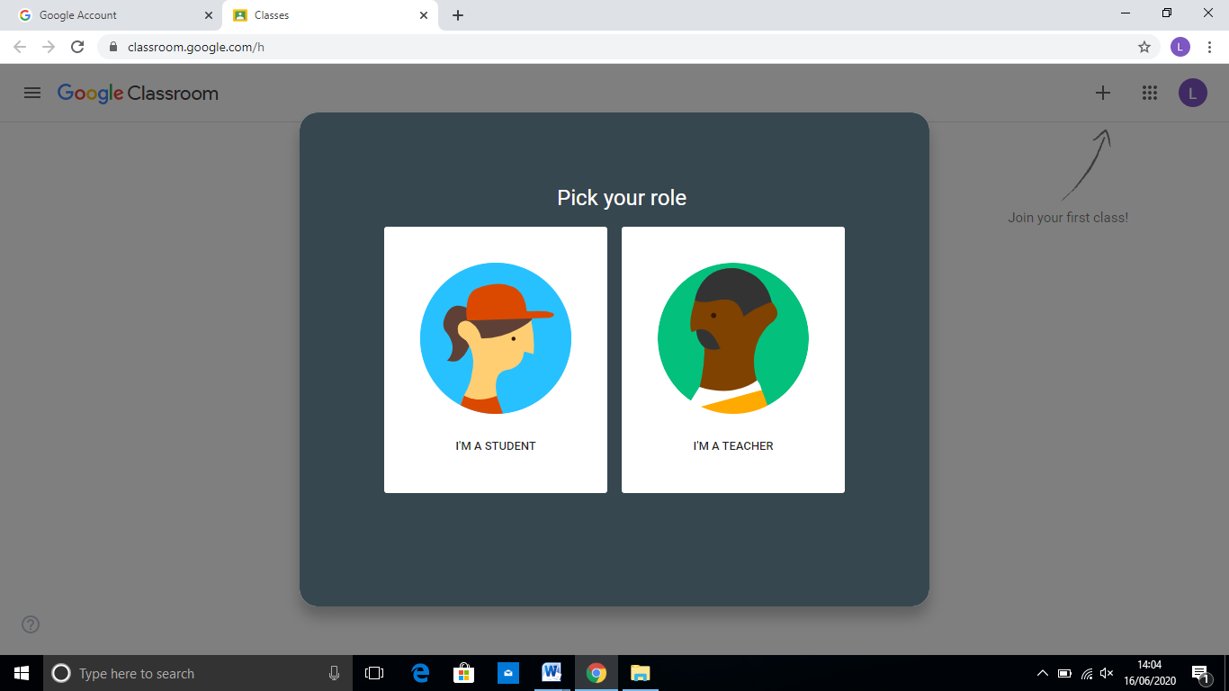
Once you go in classrooms, select the Student option.

Now you’ll need to join the Year 2 Classroom . Click on the + sign in the top right.
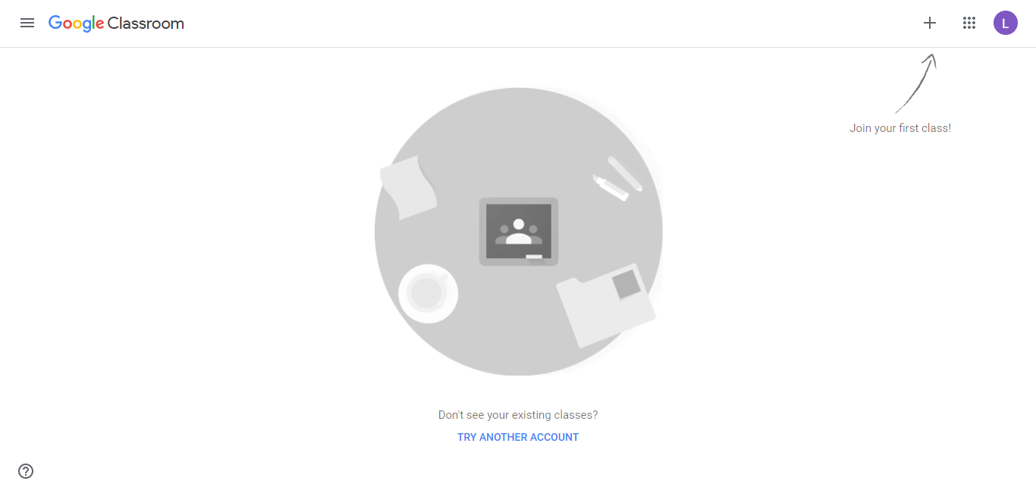

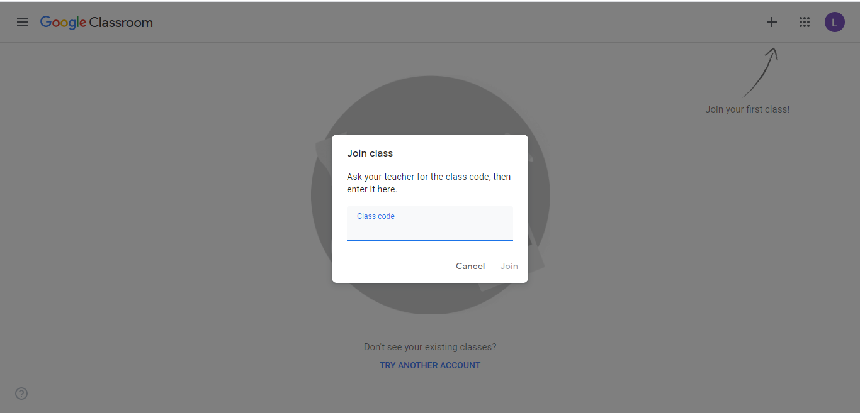
Now you will need to enter your class code which is: 2osqsaq

Once inside the classroom, you will see a screen like the one below. This is the Stream page. It will contain messages from your teacher and information about work. There is also the link to the class ‘Meet’. This is where you can connect to the class via a camera, microphone, or just listen in. HOWEVER, this will only work when the teacher goes into the class, so you might need to wait. https://meet.google.com/onb-iekc-txy?authuser=0&hs=179

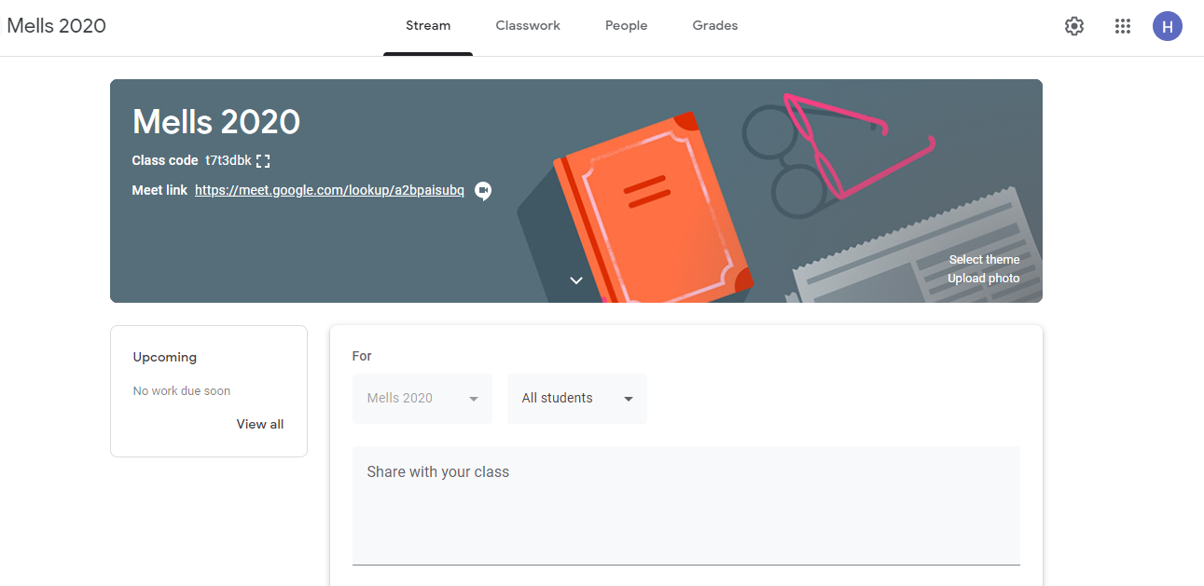

Meeting Link – only available when the teacher is present.
If you click the link, it will take you to a screen that shows if your camera and microphone are working. On this page you can click to join the ‘Meet’. If this works correctly, you will see all of the people who are in the classroom. This will only be available when the teacher is present.

From here we can discuss the work set and talk about the projects etc. that we are working on.

IMPORTANT - E- SAFETY
- Never give out your personal details to someone you don’t know.
- Never allow anyone into the classroom who is not part of the class.
- Never meet with anyone outside of class lessons.
- If you choose to use the camera, try to have a plain background behind you.
- Sit in a part of the house where it is quiet but where your parents can keep an eye on you.
- Make sure you are dressed appropriately.
- During live chat, we will always meet as a group – never 1 to 1.
- If you are ever unsure or uncomfortable about using anything on the computer or internet, make sure you speak to a trusted adult for help.

